**Course Project – Module 4  
  
College of Engineering and Information Sciences**

**Course Number: CEIS114**

# **Creating a Multiple Traffic Light Controller**

# PARTS LIST

* PC running Arduino IDE
* ESP32 Board
* Two sets of Colored LEDs: Red, Yellow and Green
* Wires
* Breadboard

# Deliverables

* Complete the Course Project PowerPoint Deliverable
* Include a picture of your circuit
* Screenshot of Arduino IDE code from your computer

# PROCEDURE

1. Connect the ESP32 Board and Check if the board is recognized by the Arduino IDE. If needed, please refer to **Module 1 Project** for connecting and configuring the ESP32 Board.
2. Insert the three LEDs ( Red, Yellow, Green) in the breadboard as shown in Figure 1
3. Connect all the wires as shown in Figure 1. Make sure to connect the Red, Yellow, and Green wires to the appropriate pins in the ESP32 Board.
4. Open the Arduino IDE and load the code shown in Figure 2

**Figure 1. Two Traffic Lights**

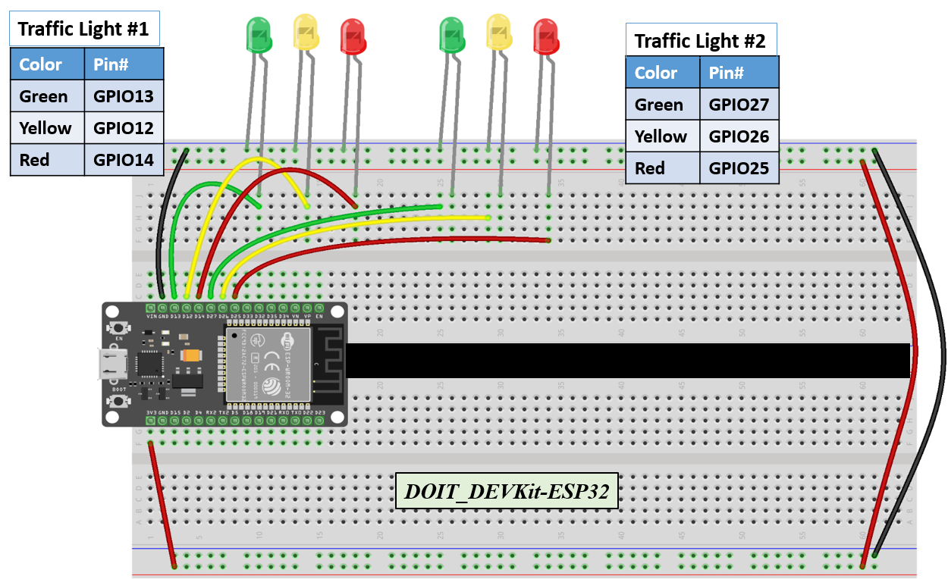

**Figure 2. Code for Two Traffic Lights (6 LEDs: Green, Yellow, Red)**

***// === Replace this text with your Name ====***

***// Module #4 project***

*// Define some labels*

*const int red_LED1 = 14; // The red LED1 is wired to ESP32 board pin GPIO14*

*const int yellow_LED1 =12; // The yellow LED1 is wired to ESP32 board pin GPIO12*

*const int green_LED1 = 13; // The green LED1 is wired to ESP32 board pin GPIO13*

*const int red_LED2 = 25; // The red LED2 is wired to Mega board pin GPIO25*

*const int yellow_LED2 = 26; // The yellow LED2 is wired to Mega board pin GPIO 26*

*const int green_LED2 = 27; // The green LED2 is wired to Mega board pin GPIO 27*

*// the setup function runs once when you press reset or power the board*

*void setup() {*

*pinMode(red_LED1, OUTPUT); // initialize digital pin GPIO14 (Red LED1) as an output.*

*pinMode(yellow_LED1, OUTPUT); // initialize digital pin GPIO12 (yellow LED1) as an output.*

*pinMode(green_LED1, OUTPUT); // initialize digital pin GPIO13 (green LED1) as an output.*

*pinMode(red_LED2, OUTPUT); // initialize digital pin GPIO25(Red LED2) as an output.*

*pinMode(yellow_LED2, OUTPUT); // initialize digital pin GPIO26 (yellow LED2) as an output.*

*pinMode(green_LED2, OUTPUT); // initialize digital pin GPIO27 (green LED2) as an output.*

*}*

*// the loop function runs over and over again forever*

*void loop() {*

*// The next three lines of code turn on the red LED1*

*digitalWrite(red_LED1, HIGH); // This should turn on the RED LED1*

*digitalWrite(yellow_LED1 , LOW); // This should turn off the YELLOW LED1*

*digitalWrite(green_LED1, LOW); // This should turn off the GREEN LED1*

*delay(1000); //Extended time for Red light#1 before the Green of the other side turns ON*

*// The next three lines of code turn on the green LED2 for 2 seconds*

*digitalWrite(red_LED2, LOW); // This should turn off the RED LED2*

*digitalWrite(yellow_LED2 , LOW); // This should turn off the YELLOW LED2*

*digitalWrite(green_LED2, HIGH); // This should turn on the GREEN LED2*

*delay(2000); // wait for 2 seconds*

*// The next three lines of code turn on the red LED1*

*digitalWrite(red_LED1, HIGH); // This should turn on the RED LED1*

*digitalWrite(yellow_LED1 , LOW); // This should turn off the YELLOW LED1*

*digitalWrite(green_LED1, LOW); // This should turn off the GREEN LED1*

*// The next three lines of code turn on the yellow LED2*

*digitalWrite(red_LED2, LOW); // This should turn off the RED LED2*

*digitalWrite(yellow_LED2 , HIGH); // This should turn on the YELLOW LED2*

*digitalWrite(green_LED2, LOW); // This should turn off the GREEN LED2*

*delay(2000); // wait for 2 seconds*

*// The next three lines of code turn on the red LED2*

*digitalWrite(red_LED2, HIGH); // This should turn on the RED LED2*

*digitalWrite(yellow_LED2 , LOW); // This should turn off the YELLOW LED2*

*digitalWrite(green_LED2, LOW); // This should turn off the GREEN LED2*

*delay(1000); //Extended time for Red light#2 before the Green of the other side turns ON*

*// The next three lines of code turn on the green LED1*

*digitalWrite(red_LED1, LOW); // This should turn off the RED LED1*

*digitalWrite(yellow_LED1 , LOW); // This should turn off the YELLOW LED1*

*digitalWrite(green_LED1, HIGH); // This should turn on the GREEN LED1*

*delay(2000); // wait for 1 second*

*// The next three lines of code turn on the yellow LED1*

*digitalWrite(red_LED1, LOW); // This should turn off the RED LED1*

*digitalWrite(yellow_LED1 , HIGH); // This should turn on the YELLOW LED1*

*digitalWrite(green_LED1, LOW); // This should turn off the GREEN LED1*

*// The next three lines of code turn on the red LED2*

*digitalWrite(red_LED2, HIGH); // This should turn on the RED LED2*

*digitalWrite(yellow_LED2 , LOW); // This should turn off the YELLOW LED2*

*digitalWrite(green_LED2, LOW); // This should turn off the GREEN LED2*

*delay(2000); // wait for 1 second*

*}*